Loading the Data Set

setwd("D:\\BABI\\Advanced_Statistics\\Dataset")  
myfactordata = read.csv("Factor-Hair-Revised.csv", header = TRUE)

Let’s do some Exploratory Data Analysis

head(myfactordata)

## ID ProdQual Ecom TechSup CompRes Advertising ProdLine SalesFImage  
## 1 1 8.5 3.9 2.5 5.9 4.8 4.9 6.0  
## 2 2 8.2 2.7 5.1 7.2 3.4 7.9 3.1  
## 3 3 9.2 3.4 5.6 5.6 5.4 7.4 5.8  
## 4 4 6.4 3.3 7.0 3.7 4.7 4.7 4.5  
## 5 5 9.0 3.4 5.2 4.6 2.2 6.0 4.5  
## 6 6 6.5 2.8 3.1 4.1 4.0 4.3 3.7  
## ComPricing WartyClaim OrdBilling DelSpeed Satisfaction  
## 1 6.8 4.7 5.0 3.7 8.2  
## 2 5.3 5.5 3.9 4.9 5.7  
## 3 4.5 6.2 5.4 4.5 8.9  
## 4 8.8 7.0 4.3 3.0 4.8  
## 5 6.8 6.1 4.5 3.5 7.1  
## 6 8.5 5.1 3.6 3.3 4.7

names(myfactordata)

## [1] "ID" "ProdQual" "Ecom" "TechSup"   
## [5] "CompRes" "Advertising" "ProdLine" "SalesFImage"   
## [9] "ComPricing" "WartyClaim" "OrdBilling" "DelSpeed"   
## [13] "Satisfaction"

dim(myfactordata)

## [1] 100 13

class(myfactordata)

## [1] "data.frame"

str(myfactordata)

## 'data.frame': 100 obs. of 13 variables:  
## $ ID : int 1 2 3 4 5 6 7 8 9 10 ...  
## $ ProdQual : num 8.5 8.2 9.2 6.4 9 6.5 6.9 6.2 5.8 6.4 ...  
## $ Ecom : num 3.9 2.7 3.4 3.3 3.4 2.8 3.7 3.3 3.6 4.5 ...  
## $ TechSup : num 2.5 5.1 5.6 7 5.2 3.1 5 3.9 5.1 5.1 ...  
## $ CompRes : num 5.9 7.2 5.6 3.7 4.6 4.1 2.6 4.8 6.7 6.1 ...  
## $ Advertising : num 4.8 3.4 5.4 4.7 2.2 4 2.1 4.6 3.7 4.7 ...  
## $ ProdLine : num 4.9 7.9 7.4 4.7 6 4.3 2.3 3.6 5.9 5.7 ...  
## $ SalesFImage : num 6 3.1 5.8 4.5 4.5 3.7 5.4 5.1 5.8 5.7 ...  
## $ ComPricing : num 6.8 5.3 4.5 8.8 6.8 8.5 8.9 6.9 9.3 8.4 ...  
## $ WartyClaim : num 4.7 5.5 6.2 7 6.1 5.1 4.8 5.4 5.9 5.4 ...  
## $ OrdBilling : num 5 3.9 5.4 4.3 4.5 3.6 2.1 4.3 4.4 4.1 ...  
## $ DelSpeed : num 3.7 4.9 4.5 3 3.5 3.3 2 3.7 4.6 4.4 ...  
## $ Satisfaction: num 8.2 5.7 8.9 4.8 7.1 4.7 5.7 6.3 7 5.5 ...

summary(myfactordata)

## ID ProdQual Ecom TechSup   
## Min. : 1.00 Min. : 5.000 Min. :2.200 Min. :1.300   
## 1st Qu.: 25.75 1st Qu.: 6.575 1st Qu.:3.275 1st Qu.:4.250   
## Median : 50.50 Median : 8.000 Median :3.600 Median :5.400   
## Mean : 50.50 Mean : 7.810 Mean :3.672 Mean :5.365   
## 3rd Qu.: 75.25 3rd Qu.: 9.100 3rd Qu.:3.925 3rd Qu.:6.625   
## Max. :100.00 Max. :10.000 Max. :5.700 Max. :8.500   
## CompRes Advertising ProdLine SalesFImage   
## Min. :2.600 Min. :1.900 Min. :2.300 Min. :2.900   
## 1st Qu.:4.600 1st Qu.:3.175 1st Qu.:4.700 1st Qu.:4.500   
## Median :5.450 Median :4.000 Median :5.750 Median :4.900   
## Mean :5.442 Mean :4.010 Mean :5.805 Mean :5.123   
## 3rd Qu.:6.325 3rd Qu.:4.800 3rd Qu.:6.800 3rd Qu.:5.800   
## Max. :7.800 Max. :6.500 Max. :8.400 Max. :8.200   
## ComPricing WartyClaim OrdBilling DelSpeed   
## Min. :3.700 Min. :4.100 Min. :2.000 Min. :1.600   
## 1st Qu.:5.875 1st Qu.:5.400 1st Qu.:3.700 1st Qu.:3.400   
## Median :7.100 Median :6.100 Median :4.400 Median :3.900   
## Mean :6.974 Mean :6.043 Mean :4.278 Mean :3.886   
## 3rd Qu.:8.400 3rd Qu.:6.600 3rd Qu.:4.800 3rd Qu.:4.425   
## Max. :9.900 Max. :8.100 Max. :6.700 Max. :5.500   
## Satisfaction   
## Min. :4.700   
## 1st Qu.:6.000   
## Median :7.050   
## Mean :6.918   
## 3rd Qu.:7.625   
## Max. :9.900

Let’s Remove the First Column - **“ID”** as it’s a categorical variable though it is nominal in nature

myfactordata = myfactordata[,-1]  
names(myfactordata)

## [1] "ProdQual" "Ecom" "TechSup" "CompRes"   
## [5] "Advertising" "ProdLine" "SalesFImage" "ComPricing"   
## [9] "WartyClaim" "OrdBilling" "DelSpeed" "Satisfaction"

attach(myfactordata)

Let’s plot the **Boxplot** for each variable to check whether there are any outliers

boxplot(myfactordata[,-1] col = "light blue")

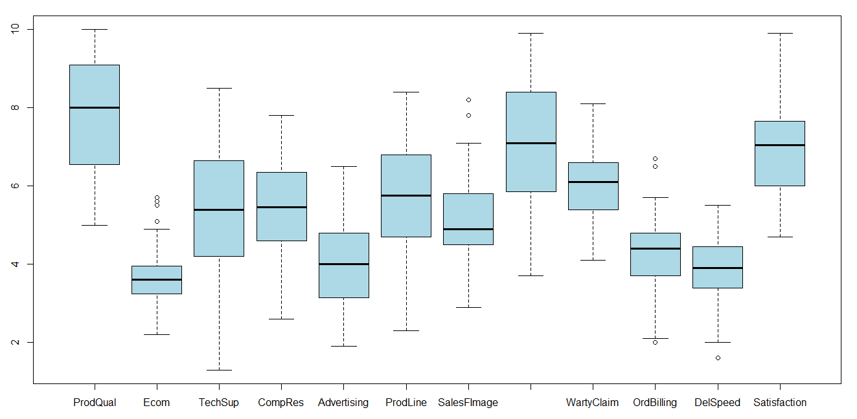

We observe that there are outliers in few of the Variables below:

* Ecommerce - Outliers on the Higher side
* SalesforceImage - Outliers on the Higher side
* Order & Billing - Outliers on both Low and Higher sides
* Deliver Speed - Outliers on the Lower side

We could infer that there are instances where Order&Billing and DeliverySpeed have even very low values which is good.

hist(myfactordata$Satisfaction, col = "Light Blue")

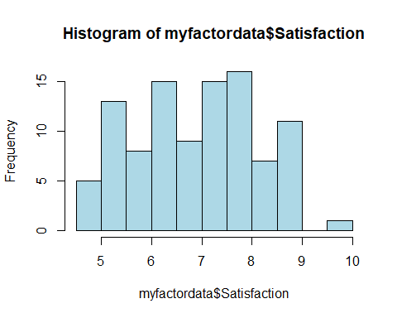

hist(myfactordata$OrdBilling, col = "Green")

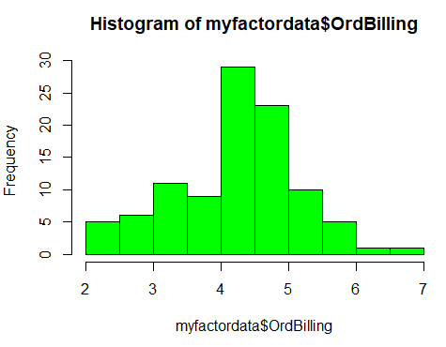

hist(myfactordata$WartyClaim, col = "Blue")

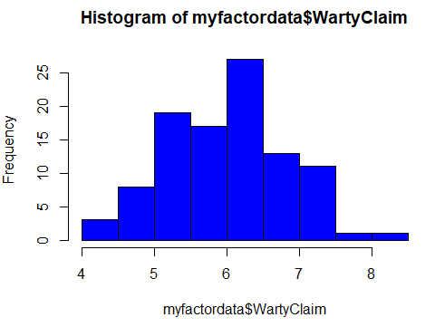

hist(myfactordata$SalesFImage,col = "Pink")

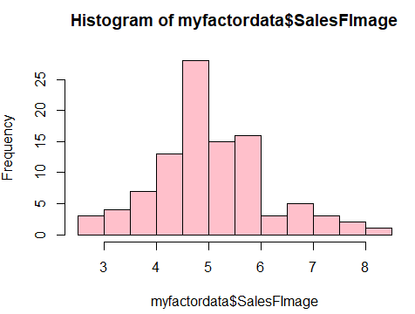

hist(myfactordata$ProdLine, col = "Red")

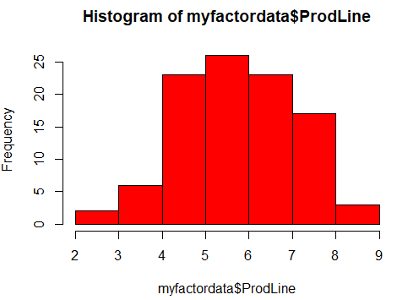

hist(myfactordata$Advertising, col = "Light green")

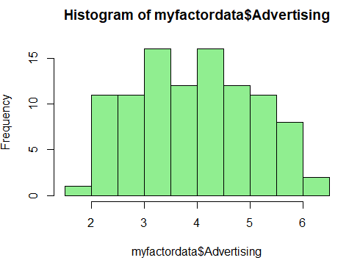

hist(myfactordata$CompRes, col = "Grey")

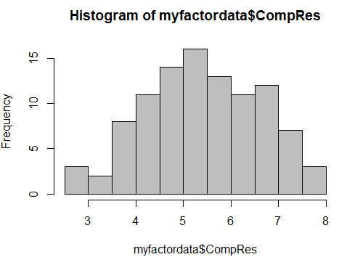

hist(myfactordata$TechSup, col = "Brown")

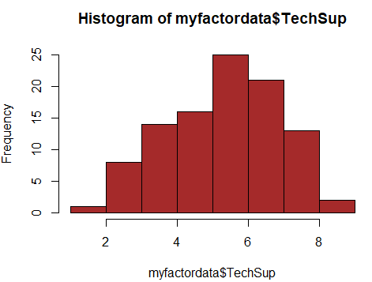

hist(myfactordata$Ecom, col = "Violet")

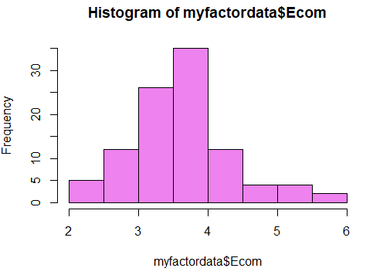

Let’s Load the required libraries before we proceed further …

library(psych)  
library(Amelia)

## Loading required package: Rcpp

## ##   
## ## Amelia II: Multiple Imputation  
## ## (Version 1.7.5, built: 2018-05-07)  
## ## Copyright (C) 2005-2020 James Honaker, Gary King and Matthew Blackwell  
## ## Refer to http://gking.harvard.edu/amelia/ for more information  
## ##

library(corrplot)

## Warning: package 'corrplot' was built under R version 3.6.2

## corrplot 0.84 loaded

library(ppcor)

## Warning: package 'ppcor' was built under R version 3.6.2

## Loading required package: MASS

Let’s check if there are any missing Variables?

missmap(myfactordata, col = c('red','black'),y.cex=0.5,x.cex=0.5)

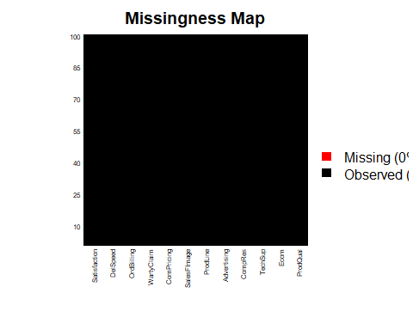

As per the missing map plotted it is clear that there is no missing data

Our end goal is to build a good Multiple Linear Regression model. However, for any Linear regression model to predict with high accuracy, it is important that the Independent variables do not have correlation between each other and have high correlation with the Dependent Variable only.

In our dataset, Satisfaction is Dependent Variable or Response Variable and rest of the variables are Independent Variable.

So, before we proceed, we need to confirm if there are any multicollinearity issue between the Independent Variables. For example, in case Salary is dependent variable explained by 2 independent variable Age and experience, both Age and experience by itself have very high correlation, so they fight with each other in trying to explain the dependent variable salary and eventually both have lesser explanatory power.

We shall run cor and corrplot to check the correlation between the independent variables.

factordatamatrix = cor(myfactordata)  
corrplot(factordatamatrix, method = "number")

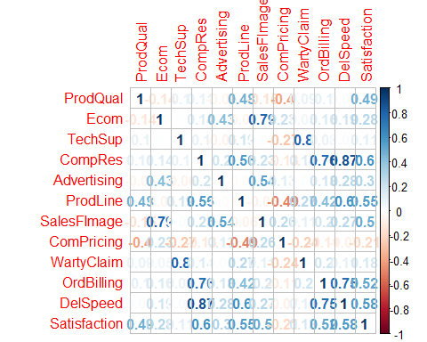

It’s clear from the plot that, there are high correlation between few of the Independent variables and it would impact the overall significance of the model built.

1. SalesForceImage and Ecommerce are highly correlated
2. WartyClaim and TechSupport are highly correlated
3. DelSpeed and Complaint Resolution are highly correlated
4. At the same time even OrderBilling and Complain Resolution also are highly correlated
5. On top of it OrdBilling and Delivery Speed are highly correlated.

As there are correlation between one Independent Variable with more than one independent Variables, there is a **multicollinearity** issue with the dataset.

Just to double confirm the multicollinearity, lets even check the p-value of the correlation to know how significant the correlations are.

pcor(myfactordata,method = "pearson")

## $estimate  
## ProdQual Ecom TechSup CompRes  
## ProdQual 1.000000000 0.1549597037 0.002424222 -0.056354142  
## Ecom 0.154959704 1.0000000000 0.082359000 -0.033513777  
## TechSup 0.002424222 0.0823590001 1.000000000 0.143603415  
## CompRes -0.056354142 -0.0335137768 0.143603415 1.000000000  
## Advertising 0.112376746 -0.0002972504 -0.059300254 -0.064806093  
## ProdLine 0.281144724 0.1538660545 -0.125349050 0.020305650  
## SalesFImage -0.376228551 0.7321011890 -0.093310796 -0.022150933  
## ComPricing -0.014021386 0.0149131857 -0.132972485 -0.004487151  
## WartyClaim -0.042752416 -0.1232553822 0.787729606 -0.109686211  
## OrdBilling 0.054523215 0.1546990521 -0.165914724 0.288344382  
## DelSpeed -0.335084210 -0.0083917930 -0.021914916 0.528932328  
## Satisfaction 0.607438787 -0.3308440834 0.055111867 0.172416347  
## Advertising ProdLine SalesFImage ComPricing  
## ProdQual 0.1123767461 0.28114472 -0.376228551 -0.014021386  
## Ecom -0.0002972504 0.15386605 0.732101189 0.014913186  
## TechSup -0.0593002540 -0.12534905 -0.093310796 -0.132972485  
## CompRes -0.0648060931 0.02030565 -0.022150933 -0.004487151  
## Advertising 1.0000000000 -0.13192319 0.262879343 -0.063298038  
## ProdLine -0.1319231866 1.00000000 -0.230170570 -0.361757904  
## SalesFImage 0.2628793429 -0.23017057 1.000000000 0.126612489  
## ComPricing -0.0632980381 -0.36175790 0.126612489 1.000000000  
## WartyClaim 0.0275909587 0.25718360 0.189300271 0.020351554  
## OrdBilling -0.0326580430 -0.28098068 -0.182359301 -0.086500869  
## DelSpeed 0.2046544064 0.50189505 0.005889925 0.190437993  
## Satisfaction -0.0449735411 0.18325156 0.660251850 -0.087467711  
## WartyClaim OrdBilling DelSpeed Satisfaction  
## ProdQual -0.04275242 0.05452322 -0.335084210 0.60743879  
## Ecom -0.12325538 0.15469905 -0.008391793 -0.33084408  
## TechSup 0.78772961 -0.16591472 -0.021914916 0.05511187  
## CompRes -0.10968621 0.28834438 0.528932328 0.17241635  
## Advertising 0.02759096 -0.03265804 0.204654406 -0.04497354  
## ProdLine 0.25718360 -0.28098068 0.501895051 0.18325156  
## SalesFImage 0.18930027 -0.18235930 0.005889925 0.66025185  
## ComPricing 0.02035155 -0.08650087 0.190437993 -0.08746771  
## WartyClaim 1.00000000 0.25984451 -0.091649002 -0.08868071  
## OrdBilling 0.25984451 1.00000000 0.350530212 0.14880055  
## DelSpeed -0.09164900 0.35053021 1.000000000 0.08955614  
## Satisfaction -0.08868071 0.14880055 0.089556143 1.00000000  
##   
## $p.value  
## ProdQual Ecom TechSup CompRes  
## ProdQual 0.000000e+00 1.447435e-01 9.819081e-01 5.977987e-01  
## Ecom 1.447435e-01 0.000000e+00 4.402823e-01 7.538375e-01  
## TechSup 9.819081e-01 4.402823e-01 0.000000e+00 1.769171e-01  
## CompRes 5.977987e-01 7.538375e-01 1.769171e-01 0.000000e+00  
## Advertising 2.916350e-01 9.977814e-01 5.787601e-01 5.439511e-01  
## ProdLine 7.269030e-03 1.476353e-01 2.391187e-01 8.493380e-01  
## SalesFImage 2.576212e-04 2.442012e-16 3.817042e-01 8.358301e-01  
## ComPricing 8.956443e-01 8.890480e-01 2.115149e-01 9.665194e-01  
## WartyClaim 6.890839e-01 2.471182e-01 3.262868e-20 3.034147e-01  
## OrdBilling 6.097697e-01 1.454288e-01 1.180864e-01 5.850710e-03  
## DelSpeed 1.245192e-03 9.374303e-01 8.375553e-01 8.359069e-08  
## Satisfaction 2.182238e-10 1.447603e-03 6.059096e-01 1.041593e-01  
## Advertising ProdLine SalesFImage ComPricing  
## ProdQual 0.29163501 7.269030e-03 2.576212e-04 0.8956443272  
## Ecom 0.99778145 1.476353e-01 2.442012e-16 0.8890479591  
## TechSup 0.57876015 2.391187e-01 3.817042e-01 0.2115148546  
## CompRes 0.54395113 8.493380e-01 8.358301e-01 0.9665194173  
## Advertising 0.00000000 2.151737e-01 1.230672e-02 0.5533828069  
## ProdLine 0.21517368 0.000000e+00 2.907563e-02 0.0004593443  
## SalesFImage 0.01230672 2.907563e-02 0.000000e+00 0.2343791374  
## ComPricing 0.55338281 4.593443e-04 2.343791e-01 0.0000000000  
## WartyClaim 0.79629803 1.440249e-02 7.394541e-02 0.8490014635  
## OrdBilling 0.75993047 7.304606e-03 8.538047e-02 0.4175555780  
## DelSpeed 0.05300070 4.664278e-07 9.560619e-01 0.0721942454  
## Satisfaction 0.67382405 8.383625e-02 1.449719e-12 0.4123500152  
## WartyClaim OrdBilling DelSpeed Satisfaction  
## ProdQual 6.890839e-01 0.6097697424 1.245192e-03 2.182238e-10  
## Ecom 2.471182e-01 0.1454287628 9.374303e-01 1.447603e-03  
## TechSup 3.262868e-20 0.1180864174 8.375553e-01 6.059096e-01  
## CompRes 3.034147e-01 0.0058507099 8.359069e-08 1.041593e-01  
## Advertising 7.962980e-01 0.7599304715 5.300070e-02 6.738241e-01  
## ProdLine 1.440249e-02 0.0073046065 4.664278e-07 8.383625e-02  
## SalesFImage 7.394541e-02 0.0853804743 9.560619e-01 1.449719e-12  
## ComPricing 8.490015e-01 0.4175555780 7.219425e-02 4.123500e-01  
## WartyClaim 0.000000e+00 0.0133877361 3.902770e-01 4.058729e-01  
## OrdBilling 1.338774e-02 0.0000000000 7.064114e-04 1.615975e-01  
## DelSpeed 3.902770e-01 0.0007064114 0.000000e+00 4.012356e-01  
## Satisfaction 4.058729e-01 0.1615974575 4.012356e-01 0.000000e+00  
##   
## $statistic  
## ProdQual Ecom TechSup CompRes Advertising  
## ProdQual 0.00000000 1.471424516 0.02274128 -0.52949015 1.060907458  
## Ecom 1.47142452 0.000000000 0.77522957 -0.31456380 -0.002788456  
## TechSup 0.02274128 0.775229571 0.00000000 1.36122814 -0.557266374  
## CompRes -0.52949015 -0.314563798 1.36122814 0.00000000 -0.609215688  
## Advertising 1.06090746 -0.002788456 -0.55726637 -0.60921569 0.000000000  
## ProdLine 2.74821968 1.460787002 -1.18522655 0.19052316 -1.248460807  
## SalesFImage -3.80921125 10.081854496 -0.87916864 -0.20784517 2.555921881  
## ComPricing -0.13154519 0.139913642 -1.25856891 -0.04209363 -0.594981366  
## WartyClaim -0.40142023 -1.165122048 11.99562484 -1.03519395 0.258924708  
## OrdBilling 0.51223505 1.468888754 -1.57829305 2.82489237 -0.306523103  
## DelSpeed -3.33624278 -0.078724768 -0.20562952 5.84663073 1.961341689  
## Satisfaction 7.17336519 -3.288799958 0.51778207 1.64199901 -0.422316520  
## ProdLine SalesFImage ComPricing WartyClaim OrdBilling  
## ProdQual 2.7482197 -3.80921125 -0.13154519 -0.4014202 0.5122350  
## Ecom 1.4607870 10.08185450 0.13991364 -1.1651220 1.4688888  
## TechSup -1.1852266 -0.87916864 -1.25856891 11.9956248 -1.5782930  
## CompRes 0.1905232 -0.20784517 -0.04209363 -1.0351939 2.8248924  
## Advertising -1.2484608 2.55592188 -0.59498137 0.2589247 -0.3065231  
## ProdLine 0.0000000 -2.21876450 -3.64012829 2.4965744 -2.7464786  
## SalesFImage -2.2187645 0.00000000 1.19736653 1.8084929 -1.7398559  
## ComPricing -3.6401283 1.19736653 0.00000000 0.1909540 -0.8145030  
## WartyClaim 2.4965744 1.80849286 0.19095404 0.0000000 2.5242649  
## OrdBilling -2.7464786 -1.73985585 -0.81450302 2.5242649 0.0000000  
## DelSpeed 5.4434474 0.05525335 1.81976992 -0.8633775 3.5110350  
## Satisfaction 1.7486638 8.24679932 -0.82367672 -0.8351894 1.4115877  
## DelSpeed Satisfaction  
## ProdQual -3.33624278 7.1733652  
## Ecom -0.07872477 -3.2888000  
## TechSup -0.20562952 0.5177821  
## CompRes 5.84663073 1.6419990  
## Advertising 1.96134169 -0.4223165  
## ProdLine 5.44344736 1.7486638  
## SalesFImage 0.05525335 8.2467993  
## ComPricing 1.81976992 -0.8236767  
## WartyClaim -0.86337748 -0.8351894  
## OrdBilling 3.51103503 1.4115877  
## DelSpeed 0.00000000 0.8435005  
## Satisfaction 0.84350046 0.0000000  
##   
## $n  
## [1] 100  
##   
## $gp  
## [1] 10  
##   
## $method  
## [1] "pearson"

It is evident from the **P-Values of the Correlated Variable** that there is significant Correlation, and hence it is sure we have **multicollinearity** issue.

Before we run an MLR, we shall run Linear Regression on each of the Independent Variable to see which has highest explanatory power over the dependent variable - **Satisfaction**

LinearModel_ProdQual = lm(Satisfaction~ProdQual)  
print(summary(LinearModel_ProdQual), digits = 10)

##   
## Call:  
## lm(formula = Satisfaction ~ ProdQual)  
##   
## Residuals:  
## Min 1Q Median 3Q Max   
## -1.88745536501 -0.72710926895 -0.01577047821 0.85641075592 2.25219853894   
##   
## Coefficients:  
## Estimate Std. Error t value Pr(>|t|)   
## (Intercept) 3.67592539247 0.59765313111 6.15060 1.6807e-08 ***  
## ProdQual 0.41511838765 0.07534135835 5.50983 2.9010e-07 ***  
## ---  
## Signif. codes: 0 '***' 0.001 '**' 0.01 '*' 0.05 '.' 0.1 ' ' 1  
##   
## Residual standard error: 1.046703 on 98 degrees of freedom  
## Multiple R-squared: 0.2365120037, Adjusted R-squared: 0.2287213099   
## F-statistic: 30.35827214 on 1 and 98 DF, p-value: 2.900993371e-07

LinearModel_Ecom = lm(Satisfaction~Ecom)  
print(summary(LinearModel_Ecom), digits = 10)

##   
## Call:  
## lm(formula = Satisfaction ~ Ecom)  
##   
## Residuals:  
## Min 1Q Median 3Q Max   
## -2.37199680537 -0.78970680258 0.04958502808 0.68084501128 2.34579593920   
##   
## Coefficients:  
## Estimate Std. Error t value Pr(>|t|)   
## (Intercept) 5.1515676717 0.6161439235 8.36098 4.2799e-13 ***  
## Ecom 0.4810545556 0.1648516480 2.91811 0.0043677 **   
## ---  
## Signif. codes: 0 '***' 0.001 '**' 0.01 '*' 0.05 '.' 0.1 ' ' 1  
##   
## Residual standard error: 1.149024 on 98 degrees of freedom  
## Multiple R-squared: 0.07994474333, Adjusted R-squared: 0.07055642438   
## F-statistic: 8.515341649 on 1 and 98 DF, p-value: 0.00436771189

LinearModel_TechSup = lm(Satisfaction~TechSup)  
print(summary(LinearModel_TechSup), digits = 10)

##   
## Call:  
## lm(formula = Satisfaction ~ TechSup)  
##   
## Residuals:  
## Min 1Q Median 3Q Max   
## -2.26136458412 -0.93296546817 0.04301965393 0.82501474853 2.85617236807   
##   
## Coefficients:  
## Estimate Std. Error t value Pr(>|t|)   
## (Intercept) 6.44757125761 0.43592102077 14.79069 < 2e-16 ***  
## TechSup 0.08768476093 0.07816511212 1.12179 0.26469   
## ---  
## Signif. codes: 0 '***' 0.001 '**' 0.01 '*' 0.05 '.' 0.1 ' ' 1  
##   
## Residual standard error: 1.190287 on 98 degrees of freedom  
## Multiple R-squared: 0.01267812466, Adjusted R-squared: 0.00260341165   
## F-statistic: 1.258410502 on 1 and 98 DF, p-value: 0.2646932926

LinearModel_CompRes = lm(Satisfaction~CompRes)  
print(summary(LinearModel_CompRes), digits = 10)

##   
## Call:  
## lm(formula = Satisfaction ~ CompRes)  
##   
## Residuals:  
## Min 1Q Median 3Q Max   
## -2.40449919620 -0.66163999790 0.04498711986 0.63036912473 2.70949298440   
##   
## Coefficients:  
## Estimate Std. Error t value Pr(>|t|)   
## (Intercept) 3.6800454610 0.4428476912 8.30996 5.5081e-13 ***  
## CompRes 0.5949934838 0.0794596537 7.48799 3.0853e-11 ***  
## ---  
## Signif. codes: 0 '***' 0.001 '**' 0.01 '*' 0.05 '.' 0.1 ' ' 1  
##   
## Residual standard error: 0.95538 on 98 degrees of freedom  
## Multiple R-squared: 0.3639257693, Adjusted R-squared: 0.3574352159   
## F-statistic: 56.07006804 on 1 and 98 DF, p-value: 3.085348525e-11

LinearModel_Advertising = lm(Satisfaction~Advertising)  
print(summary(LinearModel_Advertising), digits = 10)

##   
## Call:  
## lm(formula = Satisfaction ~ Advertising)  
##   
## Residuals:  
## Min 1Q Median 3Q Max   
## -2.34032784538 -0.92755285135 0.05576855166 0.79773109043 2.53412216655   
##   
## Coefficients:  
## Estimate Std. Error t value Pr(>|t|)   
## (Intercept) 5.6259207826 0.4236826403 13.27862 < 2.22e-16 ***  
## Advertising 0.3222142687 0.1017533427 3.16662 0.0020561 **   
## ---  
## Signif. codes: 0 '***' 0.001 '**' 0.01 '*' 0.05 '.' 0.1 ' ' 1  
##   
## Residual standard error: 1.140954 on 98 degrees of freedom  
## Multiple R-squared: 0.09282348879, Adjusted R-squared: 0.08356658562   
## F-statistic: 10.02748835 on 1 and 98 DF, p-value: 0.002056064961

LinearModel_ProdLine = lm(Satisfaction~ProdLine)  
print(summary(LinearModel_ProdLine), digits = 10)

##   
## Call:  
## lm(formula = Satisfaction ~ ProdLine)  
##   
## Residuals:  
## Min 1Q Median 3Q Max   
## -2.3633673055 -0.7794968251 0.1096631877 0.7604509904 1.7373079539   
##   
## Coefficients:  
## Estimate Std. Error t value Pr(>|t|)   
## (Intercept) 4.02203313530 0.45471260765 8.84522 3.8680e-14 ***  
## ProdLine 0.49887456756 0.07641343799 6.52862 2.9531e-09 ***  
## ---  
## Signif. codes: 0 '***' 0.001 '**' 0.01 '*' 0.05 '.' 0.1 ' ' 1  
##   
## Residual standard error: 1.000017 on 98 degrees of freedom  
## Multiple R-squared: 0.3031008275, Adjusted R-squared: 0.2959896114   
## F-statistic: 42.6229249 on 1 and 98 DF, p-value: 2.953079537e-09

LinearModel_SalesFImage = lm(Satisfaction~SalesFImage)  
print(summary(LinearModel_SalesFImage), digits = 10)

##   
## Call:  
## lm(formula = Satisfaction ~ SalesFImage)  
##   
## Residuals:  
## Min 1Q Median 3Q Max   
## -2.2164044938 -0.5884256978 0.1837764226 0.6921700614 2.0727658206   
##   
## Coefficients:  
## Estimate Std. Error t value Pr(>|t|)   
## (Intercept) 4.06982925602 0.50874011068 7.99982 2.5392e-12 ***  
## SalesFImage 0.55595759203 0.09721907888 5.71861 1.1643e-07 ***  
## ---  
## Signif. codes: 0 '***' 0.001 '**' 0.01 '*' 0.05 '.' 0.1 ' ' 1  
##   
## Residual standard error: 1.037274 on 98 degrees of freedom  
## Multiple R-squared: 0.2502053484, Adjusted R-squared: 0.2425543826   
## F-statistic: 32.70245273 on 1 and 98 DF, p-value: 1.16431356e-07

LinearModel_ComPricing = lm(Satisfaction~ComPricing)  
print(summary(LinearModel_ComPricing), digits = 10)

##   
## Call:  
## lm(formula = Satisfaction ~ ComPricing)  
##   
## Residuals:  
## Min 1Q Median 3Q Max   
## -1.9728067755 -0.9914656222 -0.1156192718 0.9111255164 2.5844849035   
##   
## Coefficients:  
## Estimate Std. Error t value Pr(>|t|)   
## (Intercept) 8.03856195765 0.54426927455 14.76946 < 2e-16 ***  
## ComPricing -0.16067708025 0.07621294255 -2.10827 0.037559 *   
## ---  
## Signif. codes: 0 '***' 0.001 '**' 0.01 '*' 0.05 '.' 0.1 ' ' 1  
##   
## Residual standard error: 1.17163 on 98 degrees of freedom  
## Multiple R-squared: 0.04338709402, Adjusted R-squared: 0.03362573784   
## F-statistic: 4.444781361 on 1 and 98 DF, p-value: 0.03755876831

LinearModel_WartyClaim = lm(Satisfaction~WartyClaim)  
print(summary(LinearModel_WartyClaim), digits = 10)

##   
## Call:  
## lm(formula = Satisfaction ~ WartyClaim)  
##   
## Residuals:  
## Min 1Q Median 3Q Max   
## -2.36503725661 -0.90201780982 0.03019303992 0.90763418619 2.88984503593   
##   
## Coefficients:  
## Estimate Std. Error t value Pr(>|t|)   
## (Intercept) 5.3580771769 0.8813473789 6.07942 2.3214e-08 ***  
## WartyClaim 0.2581371542 0.1445354304 1.78598 0.077196 .   
## ---  
## Signif. codes: 0 '***' 0.001 '**' 0.01 '*' 0.05 '.' 0.1 ' ' 1  
##   
## Residual standard error: 1.178873 on 98 degrees of freedom  
## Multiple R-squared: 0.03152216275, Adjusted R-squared: 0.02163973584   
## F-statistic: 3.189718785 on 1 and 98 DF, p-value: 0.07719560357

LinearModel_OrdBilling = lm(Satisfaction~OrdBilling)  
print(summary(LinearModel_OrdBilling), digits = 10)

##   
## Call:  
## lm(formula = Satisfaction ~ OrdBilling)  
##   
## Residuals:  
## Min 1Q Median 3Q Max   
## -2.4005118743 -0.7070997382 -0.0344037578 0.7340083782 2.9672718928   
##   
## Coefficients:  
## Estimate Std. Error t value Pr(>|t|)   
## (Intercept) 4.0540526111 0.4839652782 8.37674 3.9589e-13 ***  
## OrdBilling 0.6694594177 0.1105779647 6.05418 2.6020e-08 ***  
## ---  
## Signif. codes: 0 '***' 0.001 '**' 0.01 '*' 0.05 '.' 0.1 ' ' 1  
##   
## Residual standard error: 1.021944 on 98 degrees of freedom  
## Multiple R-squared: 0.2722041884, Adjusted R-squared: 0.2647777005   
## F-statistic: 36.65315193 on 1 and 98 DF, p-value: 2.601982011e-08

LinearModel_DelSpeed = lm(Satisfaction~DelSpeed)  
print(summary(LinearModel_DelSpeed), digits = 10)

##   
## Call:  
## lm(formula = Satisfaction ~ DelSpeed)  
##   
## Residuals:  
## Min 1Q Median 3Q Max   
## -2.2247518745 -0.5484558168 0.0879641351 0.5446155834 2.5943221399   
##   
## Coefficients:  
## Estimate Std. Error t value Pr(>|t|)   
## (Intercept) 3.2790720669 0.5293818910 6.19415 1.3784e-08 ***  
## DelSpeed 0.9364199519 0.1338813670 6.99440 3.3005e-10 ***  
## ---  
## Signif. codes: 0 '***' 0.001 '**' 0.01 '*' 0.05 '.' 0.1 ' ' 1  
##   
## Residual standard error: 0.9783458 on 98 degrees of freedom  
## Multiple R-squared: 0.3329777866, Adjusted R-squared: 0.3261714375   
## F-statistic: 48.92164373 on 1 and 98 DF, p-value: 3.300472407e-10

We can observe that only 3 of the independent variables have at least 30% of the explanatory power over the dependent variable Satisfaction. The 3 independent variables are - **Delivery Speed, warranty Claim and Complaint Resolution**

Now let’s try to run MLR:

MLRModel_Factor = lm(Satisfaction~., data = myfactordata[,-12])  
summary(MLRModel_Factor)

##   
## Call:  
## lm(formula = Satisfaction ~ ., data = myfactordata[, -12])  
##   
## Residuals:  
## Min 1Q Median 3Q Max   
## -1.43005 -0.31165 0.07621 0.37190 0.90120   
##   
## Coefficients:  
## Estimate Std. Error t value Pr(>|t|)   
## (Intercept) -0.66961 0.81233 -0.824 0.41199   
## ProdQual 0.37137 0.05177 7.173 2.18e-10 ***  
## Ecom -0.44056 0.13396 -3.289 0.00145 **   
## TechSup 0.03299 0.06372 0.518 0.60591   
## CompRes 0.16703 0.10173 1.642 0.10416   
## Advertising -0.02602 0.06161 -0.422 0.67382   
## ProdLine 0.14034 0.08025 1.749 0.08384 .   
## SalesFImage 0.80611 0.09775 8.247 1.45e-12 ***  
## ComPricing -0.03853 0.04677 -0.824 0.41235   
## WartyClaim -0.10298 0.12330 -0.835 0.40587   
## OrdBilling 0.14635 0.10367 1.412 0.16160   
## DelSpeed 0.16570 0.19644 0.844 0.40124   
## ---  
## Signif. codes: 0 '***' 0.001 '**' 0.01 '*' 0.05 '.' 0.1 ' ' 1  
##   
## Residual standard error: 0.5623 on 88 degrees of freedom  
## Multiple R-squared: 0.8021, Adjusted R-squared: 0.7774   
## F-statistic: 32.43 on 11 and 88 DF, p-value: < 2.2e-16

Adjusted R-squared is 0.7774, so the model seems have the capacity to explain ~78% variations in the Dependent variable based on the Variation in the Independent variable. Also, we can see that only 3 of the independent variables have high confidence interval than others. F-statistic of 32.43 at p-value: < 2.2e-16 is good, and implied that our Model is good predictor.

Linear Equation of the Model:

**Satisfaction = - 0.669 + 0.371*ProdQual - 0.440*Ecom + 0.032*TechSup + 0.167*CompRes - 0.026*Advertising + 0.140ProdLine + 0.806*SalesFImage - 0.038*CompPricing - 0.102*WartyClaim + 0.146*OrdBilling + 0.165*DelSpeed**

Let’s also try plotting the actual and predicted satisfaction by the Model

Results = data.frame(myfactordata, fitted.value=fitted(MLRModel_Factor), residual = resid(MLRModel_Factor))  
head(Results)

## ProdQual Ecom TechSup CompRes Advertising ProdLine SalesFImage  
## 1 8.5 3.9 2.5 5.9 4.8 4.9 6.0  
## 2 8.2 2.7 5.1 7.2 3.4 7.9 3.1  
## 3 9.2 3.4 5.6 5.6 5.4 7.4 5.8  
## 4 6.4 3.3 7.0 3.7 4.7 4.7 4.5  
## 5 9.0 3.4 5.2 4.6 2.2 6.0 4.5  
## 6 6.5 2.8 3.1 4.1 4.0 4.3 3.7  
## ComPricing WartyClaim OrdBilling DelSpeed Satisfaction fitted.value  
## 1 6.8 4.7 5.0 3.7 8.2 7.835026  
## 2 5.3 5.5 3.9 4.9 5.7 6.688189  
## 3 4.5 6.2 5.4 4.5 8.9 8.666668  
## 4 8.8 7.0 4.3 3.0 4.8 5.333509  
## 5 6.8 6.1 4.5 3.5 7.1 6.875291  
## 6 8.5 5.1 3.6 3.3 4.7 5.000756  
## residual  
## 1 0.3649742  
## 2 -0.9881894  
## 3 0.2333317  
## 4 -0.5335090  
## 5 0.2247092  
## 6 -0.3007562

plot(Results$Satisfaction)  
lines(Results$Satisfaction, col = "red")  
lines(Results$fitted.value, col = "Blue")

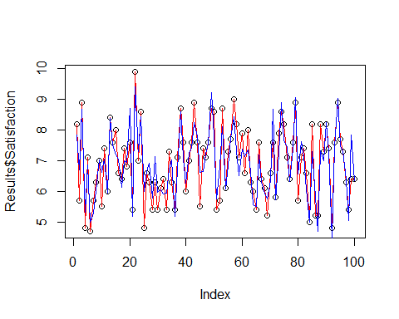

Plot shows, that the Predicted values are almost overlapping with the actual values. So the Model is generating prediction close enough.

We assume in regression that the independent variables are not correlated and they are all independent, but we saw earlier that there is correlation between few independent variables. Let’s check the **Variable Inflation Factor (VIF)** values of the independent variables to identify the variable causing multicollinearity issue. Higher the VIF value, higher the issue.

library(caret)

## Warning: package 'caret' was built under R version 3.6.2

## Loading required package: lattice

## Loading required package: ggplot2

## Warning: package 'ggplot2' was built under R version 3.6.2

##   
## Attaching package: 'ggplot2'

## The following objects are masked from 'package:psych':  
##   
## %+%, alpha

library(car)

## Warning: package 'car' was built under R version 3.6.2

## Loading required package: carData

##   
## Attaching package: 'car'

## The following object is masked from 'package:psych':  
##   
## logit

vif(MLRModel_Factor)

## ProdQual Ecom TechSup CompRes Advertising ProdLine   
## 1.635797 2.756694 2.976796 4.730448 1.508933 3.488185   
## SalesFImage ComPricing WartyClaim OrdBilling DelSpeed   
## 3.439420 1.635000 3.198337 2.902999 6.516014

It is apparent that **Delivery Speed** and **Complaint Resolution** are creating more multicollinearity issue.

As it is evident that there is multicollinearity issue with the independent variables, let’s try to perform **Factor Analysis with PCA** and group the independent variables which are closely correlated. And use the Newly created Factors to build another model and check its validity. To start with PCA, lets calculate the **Eigen Value**  to determine number of factors to consider.

**Calculating Eigen Value**

ev = eigen(cor(myfactordata[,-12]))  
ev

## eigen() decomposition  
## $values  
## [1] 3.42697133 2.55089671 1.69097648 1.08655606 0.60942409 0.55188378  
## [7] 0.40151815 0.24695154 0.20355327 0.13284158 0.09842702  
##   
## $vectors  
## [,1] [,2] [,3] [,4] [,5]  
## [1,] -0.1337896 0.31349802 0.06227164 0.6431362 0.23166620  
## [2,] -0.1659528 -0.44650918 -0.23524791 0.2723803 0.42228844  
## [3,] -0.1576926 0.23096734 -0.61095105 -0.1933931 -0.02395667  
## [4,] -0.4706836 -0.01944394 0.21035078 -0.2063204 0.02865743  
## [5,] -0.1837350 -0.36366471 -0.08809705 0.3178945 -0.80387024  
## [6,] -0.3867652 0.28478056 0.11627864 0.2029023 0.11667416  
## [7,] -0.2036696 -0.47069599 -0.24134210 0.2221772 0.20437283  
## [8,] 0.1516886 -0.41345650 0.05304529 -0.3335435 0.24892601  
## [9,] -0.2129336 0.19167191 -0.59856398 -0.1853020 -0.03292706  
## [10,] -0.4372177 -0.02639905 0.16892981 -0.2368536 0.02675377  
## [11,] -0.4730891 -0.07305172 0.23262477 -0.1973299 -0.03543294  
## [,6] [,7] [,8] [,9] [,10]  
## [1,] 0.56456996 -0.191641317 0.13547311 0.03132810 -0.06659717  
## [2,] -0.26325703 -0.059626208 -0.12202642 -0.54251104 -0.28155772  
## [3,] 0.10876896 0.017199915 0.46470964 -0.35929961 0.38817090  
## [4,] 0.02815231 0.008499596 0.51339754 0.09324751 -0.53467243  
## [5,] 0.20056937 0.063069619 -0.05347713 -0.15468169 -0.03715799  
## [6,] -0.09819533 0.608147555 -0.33320710 -0.08415534 0.23479794  
## [7,] -0.10497225 -0.001437351 0.16910665 0.64489911 0.35341191  
## [8,] 0.70973595 0.308248871 -0.09883227 -0.09414389 0.04518224  
## [9,] 0.13983966 0.030640243 -0.44354040 0.31756604 -0.43534752  
## [10,] 0.11947974 -0.659319893 -0.36601754 -0.09907265 0.30386545  
## [11,] -0.02979992 0.234239274 0.06539059 -0.02188514 0.12010386  
## [,11]  
## [1,] -0.18279209  
## [2,] -0.06233863  
## [3,] 0.05192956  
## [4,] 0.36253352  
## [5,] 0.08118684  
## [6,] 0.38507778  
## [7,] 0.08469869  
## [8,] 0.10295751  
## [9,] -0.12893245  
## [10,] 0.19415064  
## [11,] -0.77563222

EigenValue=ev$values  
EigenValue

## [1] 3.42697133 2.55089671 1.69097648 1.08655606 0.60942409 0.55188378  
## [7] 0.40151815 0.24695154 0.20355327 0.13284158 0.09842702

Let’s plot the **Scree plot** and apply Kaiser rule to choose the number of factors.

**Scree Plot**

Factor=c(1:11)  
Factor

## [1] 1 2 3 4 5 6 7 8 9 10 11

Scree=data.frame(Factor, Eigenvalue)  
plot(Scree,main="Scree Plot", col="Blue",ylim=c(0,4))  
lines(Scree,col="Red")

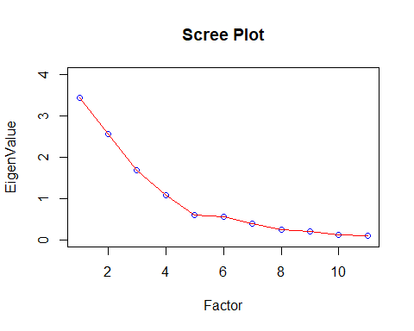

There are 4 Eigen values above 1 and others are flattened and are below 1, so as per **Kaiser rule** lets go with 4 Factors for PCA.

**Running UnRotated PCA**

library(psych)  
Unrotate=principal(myfactordata[,-12], nfactors=4, rotate="none")  
print(Unrotate,digits=3)

## Principal Components Analysis  
## Call: principal(r = myfactordata[, -12], nfactors = 4, rotate = "none")  
## Standardized loadings (pattern matrix) based upon correlation matrix  
## PC1 PC2 PC3 PC4 h2 u2 com  
## ProdQual 0.248 -0.501 -0.081 0.670 0.768 0.2320 2.20  
## Ecom 0.307 0.713 0.306 0.284 0.777 0.2229 2.14  
## TechSup 0.292 -0.369 0.794 -0.202 0.893 0.1069 1.87  
## CompRes 0.871 0.031 -0.274 -0.215 0.881 0.1187 1.33  
## Advertising 0.340 0.581 0.115 0.331 0.576 0.4240 2.38  
## ProdLine 0.716 -0.455 -0.151 0.212 0.787 0.2129 2.01  
## SalesFImage 0.377 0.752 0.314 0.232 0.859 0.1406 2.10  
## ComPricing -0.281 0.660 -0.069 -0.348 0.641 0.3594 1.94  
## WartyClaim 0.394 -0.306 0.778 -0.193 0.892 0.1078 1.98  
## OrdBilling 0.809 0.042 -0.220 -0.247 0.766 0.2339 1.35  
## DelSpeed 0.876 0.117 -0.302 -0.206 0.914 0.0856 1.40  
##   
## PC1 PC2 PC3 PC4  
## SS loadings 3.427 2.551 1.691 1.087  
## Proportion Var 0.312 0.232 0.154 0.099  
## Cumulative Var 0.312 0.543 0.697 0.796  
## Proportion Explained 0.391 0.291 0.193 0.124  
## Cumulative Proportion 0.391 0.683 0.876 1.000  
##   
## Mean item complexity = 1.9  
## Test of the hypothesis that 4 components are sufficient.  
##   
## The root mean square of the residuals (RMSR) is 0.06   
## with the empirical chi square 39.023 with prob < 0.00177   
##   
## Fit based upon off diagonal values = 0.968

UnrotatedProfile=plot(Unrotate,row.names(Unrotate$loadings))

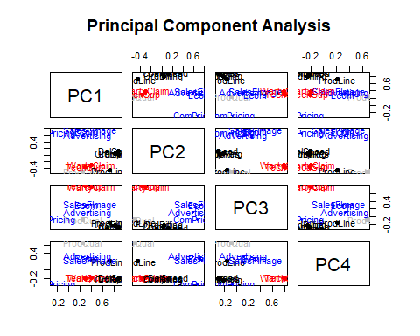

Unrotated output of PCA does not help us group the independent variables correctly, so let’s get the rotated PCA loadings to determine the grouping

**Running UnRotated PCA**

Rotate=principal(myfactordata[,-12],nfactors=4,rotate="varimax")  
print(Rotate,digits=3)

## Principal Components Analysis  
## Call: principal(r = myfactordata[, -12], nfactors = 4, rotate = "varimax")  
## Standardized loadings (pattern matrix) based upon correlation matrix  
## RC1 RC2 RC3 RC4 h2 u2 com  
## ProdQual 0.002 -0.013 -0.033 0.876 0.768 0.2320 1.00  
## Ecom 0.057 0.871 0.047 -0.117 0.777 0.2229 1.05  
## TechSup 0.018 -0.024 0.939 0.101 0.893 0.1069 1.03  
## CompRes 0.926 0.116 0.049 0.091 0.881 0.1187 1.06  
## Advertising 0.139 0.742 -0.082 0.015 0.576 0.4240 1.10  
## ProdLine 0.591 -0.064 0.146 0.642 0.787 0.2129 2.12  
## SalesFImage 0.133 0.900 0.076 -0.159 0.859 0.1406 1.12  
## ComPricing -0.085 0.226 -0.246 -0.723 0.641 0.3594 1.47  
## WartyClaim 0.110 0.055 0.931 0.102 0.892 0.1078 1.06  
## OrdBilling 0.864 0.107 0.084 0.039 0.766 0.2339 1.05  
## DelSpeed 0.938 0.177 -0.005 0.052 0.914 0.0856 1.08  
##   
## RC1 RC2 RC3 RC4  
## SS loadings 2.893 2.234 1.856 1.774  
## Proportion Var 0.263 0.203 0.169 0.161  
## Cumulative Var 0.263 0.466 0.635 0.796  
## Proportion Explained 0.330 0.255 0.212 0.203  
## Cumulative Proportion 0.330 0.586 0.797 1.000  
##   
## Mean item complexity = 1.2  
## Test of the hypothesis that 4 components are sufficient.  
##   
## The root mean square of the residuals (RMSR) is 0.06   
## with the empirical chi square 39.023 with prob < 0.00177   
##   
## Fit based upon off diagonal values = 0.968

RotatedProfile=plot(Rotate,row.names(Rotate$loadings),cex=1.0)

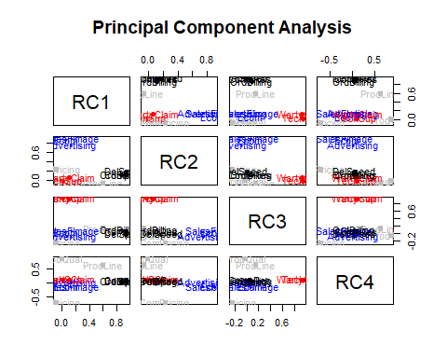

Let’s use fa function to perform PCA again just to leverage its capability to draw the grouping of independent variables in each PCA

**Grouping of Independent Variables**

Rotate1=fa(myfactordata[,-12],nfactors=4,rotate="varimax")  
fa.diagram(Rotate1)

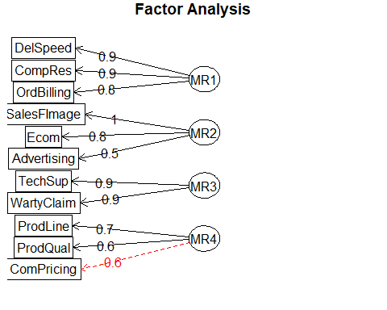

Let’s check if the new factors are significant enough?

RC1_MLR_Data = cbind(myfactordata[,c(4,10,11)],Rotate$scores[,1])  
head(RC1_MLR_Data)

## CompRes OrdBilling DelSpeed Rotate$scores[, 1]  
## 1 5.9 5.0 3.7 0.1274910  
## 2 7.2 3.9 4.9 1.2216666  
## 3 5.6 5.4 4.5 0.6158214  
## 4 3.7 4.3 3.0 -0.8446267  
## 5 4.6 4.5 3.5 -0.3197943  
## 6 4.1 3.6 3.3 -0.6470292

RC1_MLR_Data_lm = lm(Rotate$scores[, 1]~., data = RC1_MLR_Data[,-4])  
summary(RC1_MLR_Data_lm)

##   
## Call:  
## lm(formula = Rotate$scores[, 1] ~ ., data = RC1_MLR_Data[, -4])  
##   
## Residuals:  
## Min 1Q Median 3Q Max   
## -0.49232 -0.10225 0.02771 0.11943 0.36076   
##   
## Coefficients:  
## Estimate Std. Error t value Pr(>|t|)   
## (Intercept) -5.11854 0.10727 -47.715 < 2e-16 ***  
## CompRes 0.27572 0.03407 8.092 1.81e-12 ***  
## OrdBilling 0.30486 0.03367 9.053 1.61e-14 ***  
## DelSpeed 0.59544 0.05549 10.731 < 2e-16 ***  
## ---  
## Signif. codes: 0 '***' 0.001 '**' 0.01 '*' 0.05 '.' 0.1 ' ' 1  
##   
## Residual standard error: 0.1944 on 96 degrees of freedom  
## Multiple R-squared: 0.9633, Adjusted R-squared: 0.9622   
## F-statistic: 840.9 on 3 and 96 DF, p-value: < 2.2e-16

RC2_MLR_Data = cbind(myfactordata[,c(2,5,7)],Rotate$scores[,2])  
head(RC2_MLR_Data)

## Ecom Advertising SalesFImage Rotate$scores[, 2]  
## 1 3.9 4.8 6.0 0.7698686  
## 2 2.7 3.4 3.1 -1.6458617  
## 3 3.4 5.4 5.8 0.5800037  
## 4 3.3 4.7 4.5 -0.2719218  
## 5 3.4 2.2 4.5 -0.8340650  
## 6 2.8 4.0 3.7 -1.0672683

RC2_MLR_Data_lm = lm(Rotate$scores[, 2]~., data = RC2_MLR_Data[,-4])  
summary(RC2_MLR_Data_lm)

##   
## Call:  
## lm(formula = Rotate$scores[, 2] ~ ., data = RC2_MLR_Data[, -4])  
##   
## Residuals:  
## Min 1Q Median 3Q Max   
## -0.45663 -0.13507 0.01335 0.12344 0.33067   
##   
## Coefficients:  
## Estimate Std. Error t value Pr(>|t|)   
## (Intercept) -5.26482 0.10114 -52.05 <2e-16 ***  
## Ecom 0.60226 0.04254 14.16 <2e-16 ***  
## Advertising 0.31797 0.01923 16.53 <2e-16 ***  
## SalesFImage 0.34711 0.02986 11.62 <2e-16 ***  
## ---  
## Signif. codes: 0 '***' 0.001 '**' 0.01 '*' 0.05 '.' 0.1 ' ' 1  
##   
## Residual standard error: 0.1812 on 96 degrees of freedom  
## Multiple R-squared: 0.9682, Adjusted R-squared: 0.9672   
## F-statistic: 973 on 3 and 96 DF, p-value: < 2.2e-16

RC3_MLR_Data = cbind(myfactordata[,c(3,9)],Rotate$scores[,3])  
head(RC3_MLR_Data)

## TechSup WartyClaim Rotate$scores[, 3]  
## 1 2.5 4.7 -1.878446273  
## 2 5.1 5.5 -0.614030010  
## 3 5.6 6.2 0.003689252  
## 4 7.0 7.0 1.267493254  
## 5 5.2 6.1 -0.008096627  
## 6 3.1 5.1 -1.303198892

RC3_MLR_Data_lm = lm(Rotate$scores[, 3]~., data = RC3_MLR_Data[,-3])  
summary(RC3_MLR_Data_lm)

##   
## Call:  
## lm(formula = Rotate$scores[, 3] ~ ., data = RC3_MLR_Data[, -3])  
##   
## Residuals:  
## Min 1Q Median 3Q Max   
## -0.27104 -0.13002 -0.01434 0.11596 0.39519   
##   
## Coefficients:  
## Estimate Std. Error t value Pr(>|t|)   
## (Intercept) -5.58146 0.13971 -39.95 <2e-16 ***  
## TechSup 0.35318 0.01797 19.65 <2e-16 ***  
## WartyClaim 0.61007 0.03356 18.18 <2e-16 ***  
## ---  
## Signif. codes: 0 '***' 0.001 '**' 0.01 '*' 0.05 '.' 0.1 ' ' 1  
##   
## Residual standard error: 0.1653 on 97 degrees of freedom  
## Multiple R-squared: 0.9732, Adjusted R-squared: 0.9727   
## F-statistic: 1764 on 2 and 97 DF, p-value: < 2.2e-16

RC4_MLR_Data = cbind(myfactordata[,c(1,6,8)],Rotate$scores[,4])  
head(RC4_MLR_Data)

## ProdQual ProdLine ComPricing Rotate$scores[, 4]  
## 1 8.5 4.9 6.8 0.3664848  
## 2 8.2 7.9 5.3 0.8130648  
## 3 9.2 7.4 4.5 1.5699769  
## 4 6.4 4.7 8.8 -1.2541645  
## 5 9.0 6.0 6.8 0.4475377  
## 6 6.5 4.3 8.5 -1.0527792

RC4_MLR_Data_lm = lm(Rotate$scores[, 2]~., data = RC4_MLR_Data[,-4])  
summary(RC4_MLR_Data_lm)

##   
## Call:  
## lm(formula = Rotate$scores[, 2] ~ ., data = RC4_MLR_Data[, -4])  
##   
## Residuals:  
## Min 1Q Median 3Q Max   
## -1.77900 -0.68128 -0.04165 0.52498 3.10641   
##   
## Coefficients:  
## Estimate Std. Error t value Pr(>|t|)   
## (Intercept) -1.84317 1.05335 -1.750 0.0833 .  
## ProdQual 0.05856 0.08266 0.708 0.4804   
## ProdLine 0.02507 0.09250 0.271 0.7869   
## ComPricing 0.17784 0.07554 2.354 0.0206 *  
## ---  
## Signif. codes: 0 '***' 0.001 '**' 0.01 '*' 0.05 '.' 0.1 ' ' 1  
##   
## Residual standard error: 0.9852 on 96 degrees of freedom  
## Multiple R-squared: 0.05885, Adjusted R-squared: 0.02943   
## F-statistic: 2.001 on 3 and 96 DF, p-value: 0.119

**Except RC4, all other groupings are typically have more than 95% R-Squared value and P-Values are also highly significant. So, the Groupings have come out really well.**

Next let’s build the new dataset with the factors and the DV - Satisfaction.

Rotate$scores

## RC1 RC2 RC3 RC4  
## [1,] 0.12749104 0.76986860 -1.878446273 0.36648477  
## [2,] 1.22166663 -1.64586166 -0.614030010 0.81306481  
## [3,] 0.61582140 0.58000368 0.003689252 1.56997685  
## [4,] -0.84462665 -0.27192183 1.267493254 -1.25416452  
## [5,] -0.31979430 -0.83406501 -0.008096627 0.44753766  
## [6,] -0.64702925 -1.06726829 -1.303198892 -1.05277921  
## [7,] -2.62679851 -0.24588272 -0.555423494 -1.22601470  
## [8,] -0.27936394 -0.15732039 -0.749311481 -1.01464175  
## [9,] 1.05151341 -0.17228834 -0.092252815 -1.65809634  
## [10,] 0.42875382 0.76353272 -0.450377116 -0.89116595  
## [11,] -0.13580761 -0.76759698 -0.463706767 0.60634140  
## [12,] -1.45030579 1.35959912 0.437785016 -1.06981053  
## [13,] 0.62461823 2.11311565 -0.168284409 0.87466736  
## [14,] 0.42724294 -0.40405102 0.432245882 0.90236591  
## [15,] 1.43869881 0.66394839 -0.268050576 -1.04431806  
## [16,] 0.91969055 -1.05791159 -0.556847385 1.16667179  
## [17,] 0.52182175 -0.31959634 1.106009732 -1.03228845  
## [18,] 1.71349224 -0.16356534 0.254874808 -1.47834954  
## [19,] 1.16101062 -0.41943765 -0.375574495 -1.76167798  
## [20,] 0.29327394 1.77627892 -0.950139113 0.24112808  
## [21,] -0.61501848 -0.17897273 1.525943540 -1.83178487  
## [22,] -0.11282553 2.83382456 0.634265462 2.24434088  
## [23,] 0.08062000 -0.35141218 1.141318858 1.33498913  
## [24,] 1.94944755 -1.67141336 -0.859208476 0.50283683  
## [25,] 0.11534004 -0.01629685 0.471841920 -1.25041487  
## [26,] 0.57499258 -0.24490397 0.624292860 -1.35435360  
## [27,] 0.82896381 -0.98564797 1.042612499 0.92163700  
## [28,] 0.11695051 -1.10728007 0.379702318 -1.35959873  
## [29,] 1.15812632 -1.60628019 -0.055788125 0.79531052  
## [30,] -0.50739097 0.16192496 -1.551322987 -0.30617006  
## [31,] -0.81074131 -0.17909238 2.256638942 0.21624964  
## [32,] -1.07438259 -1.60132074 1.186706049 -0.07026025  
## [33,] -0.49992323 0.30576561 0.157100923 -0.97020760  
## [34,] 0.27885747 0.07142401 -0.032941868 -0.65628441  
## [35,] -1.21092268 0.61247373 0.275773660 -0.68907425  
## [36,] -1.37569442 -1.05901060 0.277541003 1.02901615  
## [37,] -0.62476762 -0.24359504 0.310901127 0.66051905  
## [38,] 1.36407521 0.03533514 0.111220579 0.58229289  
## [39,] 0.60127495 0.47053204 -1.291508459 -0.44567425  
## [40,] -0.58595295 1.48246242 -1.184474889 -1.03900017  
## [41,] 0.19167763 -0.38987441 -1.981705114 -0.59621998  
## [42,] 0.04337736 0.09038218 -1.165712378 0.53711635  
## [43,] 0.40978439 1.95821980 -1.094672035 0.98888677  
## [44,] 0.77547735 1.61343935 1.512055016 -1.14923990  
## [45,] 1.26977129 -1.77421869 -0.982794252 0.73741113  
## [46,] 1.06006213 0.67869812 0.324241314 -1.10289754  
## [47,] -0.12283972 -0.09120895 0.996132311 1.41658476  
## [48,] 2.09832312 0.46224836 0.840138645 -1.68134357  
## [49,] 0.15604110 0.88202250 -0.835276700 1.29848126  
## [50,] 0.22982346 0.50302016 -0.877037378 1.03687279  
## [51,] -0.94183170 -0.37565064 0.194174450 -0.65267018  
## [52,] 1.56112818 -1.90837771 -1.176496580 0.72135781  
## [53,] 0.86011758 -1.08934973 -0.241431240 0.87182584  
## [54,] -0.81818435 -0.52905894 0.539901007 0.33090833  
## [55,] 0.54057306 -0.67964718 -1.060702696 -0.81493134  
## [56,] -0.36862437 0.28299033 0.917529711 0.60437604  
## [57,] 1.97865621 1.43218345 -0.085319811 -0.83928511  
## [58,] 0.20552648 0.51721871 0.347543516 0.85780222  
## [59,] -1.34118399 0.55279292 0.326579529 1.94033636  
## [60,] 0.85269365 -1.57772836 0.565957142 0.74035745  
## [61,] 0.99335190 -1.26473291 1.700148685 0.79107349  
## [62,] -1.10480994 0.70911509 -0.152796271 0.39572776  
## [63,] -0.75921278 0.26001089 -1.188441475 0.78014681  
## [64,] -1.09474826 -1.95079477 0.427161087 -0.14850194  
## [65,] -1.20922892 0.15287985 0.577570622 -0.51556079  
## [66,] 1.34313803 0.53659415 -1.039141561 -1.24941075  
## [67,] 0.90215965 -0.58791187 2.062390350 -1.31875384  
## [68,] 0.42318247 -0.24798003 -0.301264201 -0.84662237  
## [69,] -0.87487795 -0.60376193 -0.997620068 -0.52944051  
## [70,] 0.14372369 -0.15149397 -1.275988102 -1.00015303  
## [71,] 0.34387385 2.05641521 0.686346140 0.09426189  
## [72,] -1.16028876 -0.18463387 -1.205197353 0.71392258  
## [73,] 0.92620350 1.31556747 -1.869872622 -0.55887325  
## [74,] -0.56659595 1.40049678 1.226627789 1.34965616  
## [75,] -0.29927186 0.87194345 -0.294625640 0.30300903  
## [76,] -0.89076271 0.23334622 1.037887857 1.61337977  
## [77,] -0.35535699 0.14354788 2.057316893 -0.63270298  
## [78,] 0.21054781 0.34218260 1.073262401 0.30917078  
## [79,] 1.12960563 0.64023318 0.441396478 1.46536309  
## [80,] -1.53178615 0.28775431 0.032504303 -0.31110748  
## [81,] -0.84995072 -0.24812793 0.452562850 1.53107516  
## [82,] 0.02821132 -0.91638751 0.493585747 0.40440014  
## [83,] -1.39215814 -0.98489128 0.207609940 0.62550901  
## [84,] -2.48589153 -0.73564594 1.633547463 -1.44488070  
## [85,] 1.00347560 -1.78211709 0.797684019 -0.01141758  
## [86,] -0.82905678 -0.41939997 -1.080457442 -0.45156381  
## [87,] -1.42542804 -0.29820535 -2.155317026 -1.27019948  
## [88,] 1.07076650 -1.29822928 1.400760179 0.04006707  
## [89,] 0.08823132 -0.05909838 0.134228700 0.23513720  
## [90,] 1.07621515 2.37671168 1.892951438 -1.01341980  
## [91,] -0.78483349 0.46274897 1.391773475 0.61318828  
## [92,] -2.34793070 -0.26426141 -0.534487111 -1.18940207  
## [93,] 0.29898878 0.20636519 -0.371416070 1.20810631  
## [94,] 1.10722906 0.37021414 0.053771549 1.44542651  
## [95,] -0.79676401 0.71175008 -1.087719898 1.06131961  
## [96,] -0.11270919 0.39627233 0.048312077 0.34767120  
## [97,] -0.20833274 -0.25264090 -1.880921516 -0.32081680  
## [98,] -1.58596201 -1.12347151 -1.337515839 1.23670188  
## [99,] -0.32827278 1.90243479 0.140227444 -0.12061112  
## [100,] -0.62744070 0.21100398 -0.748923176 -0.69590553

PCA_MLR_Data = cbind(myfactordata[12], Rotate$scores)  
head(PCA_MLR_Data)

## Satisfaction RC1 RC2 RC3 RC4  
## 1 8.2 0.1274910 0.7698686 -1.878446273 0.3664848  
## 2 5.7 1.2216666 -1.6458617 -0.614030010 0.8130648  
## 3 8.9 0.6158214 0.5800037 0.003689252 1.5699769  
## 4 4.8 -0.8446267 -0.2719218 1.267493254 -1.2541645  
## 5 7.1 -0.3197943 -0.8340650 -0.008096627 0.4475377  
## 6 4.7 -0.6470292 -1.0672683 -1.303198892 -1.0527792

**Naming the Factored Groups**

|  |  |  |  |
| --- | --- | --- | --- |
| **Factors** | **Variables** | **Group Label** | **Short Description about Grouping** |
| RC1 | DelSpeed,CompRes,OrdBilling | Sales | These IVs mostly explains about the underlying Sales/Purchase factor. |
| RC2 | SalesFImage,Ecom,Advertising | Brand Name | These IVs mostly explains about the underlying factors they impact the Product Brand Name. |
| RC3 | WartyClaim,TechSup | Support | These IVs mostly explains about the underlying factors that contributes to Product Support. |
| RC4 | ProdLine,ProdQual,CompPricing | Prod Segment | These IVs mostly explains about the underlying factors that segment the product. |

names(PCA_MLR_Data) <- c("Satisfaction", "**Sales**", "**Brand_Name**",  
 "**Support**", "**Prod_Segment**")  
head(PCA_MLR_Data)

## Satisfaction Sales Brand_Name Support Prod_Segment  
## 1 8.2 0.1274910 0.7698686 -1.878446273 0.3664848  
## 2 5.7 1.2216666 -1.6458617 -0.614030010 0.8130648  
## 3 8.9 0.6158214 0.5800037 0.003689252 1.5699769  
## 4 4.8 -0.8446267 -0.2719218 1.267493254 -1.2541645  
## 5 7.1 -0.3197943 -0.8340650 -0.008096627 0.4475377  
## 6 4.7 -0.6470292 -1.0672683 -1.303198892 -1.0527792

PCA_MLR_Data_lm = lm(Satisfaction ~ ., data = PCA_MLR_Data[,-1])  
summary(PCA_MLR_Data_lm)

##   
## Call:  
## lm(formula = Satisfaction ~ ., data = PCA_MLR_Data[, -1])  
##   
## Residuals:  
## Min 1Q Median 3Q Max   
## -1.6308 -0.4996 0.1372 0.4623 1.5228   
##   
## Coefficients:  
## Estimate Std. Error t value Pr(>|t|)   
## (Intercept) 6.91800 0.07089 97.589 < 2e-16 ***  
## Sales 0.61805 0.07125 8.675 1.12e-13 ***  
## Brand_Name 0.50973 0.07125 7.155 1.74e-10 ***  
## Support 0.06714 0.07125 0.942 0.348   
## Prod_Segment 0.54032 0.07125 7.584 2.24e-11 ***  
## ---  
## Signif. codes: 0 '***' 0.001 '**' 0.01 '*' 0.05 '.' 0.1 ' ' 1  
##   
## Residual standard error: 0.7089 on 95 degrees of freedom  
## Multiple R-squared: 0.6605, Adjusted R-squared: 0.6462   
## F-statistic: 46.21 on 4 and 95 DF, p-value: < 2.2e-16

**R-Squared is lower than our initial Model…**

**‘Support’** Factor is having low significance when compared to other Factors, so let’s try to remove it and check if the model improves.

PCA_MLR_Data_lm1 = lm(Satisfaction ~ Sales+Brand_Name+Prod_Segment, data = PCA_MLR_Data[,-1])  
summary(PCA_MLR_Data_lm1)

##   
## Call:  
## lm(formula = Satisfaction ~ Sales + Brand_Name + Prod_Segment,   
## data = PCA_MLR_Data[, -1])  
##   
## Residuals:  
## Min 1Q Median 3Q Max   
## -1.69684 -0.49928 0.09364 0.46420 1.57638   
##   
## Coefficients:  
## Estimate Std. Error t value Pr(>|t|)   
## (Intercept) 6.91800 0.07085 97.646 < 2e-16 ***  
## Sales 0.61805 0.07120 8.680 1.01e-13 ***  
## Brand_Name 0.50973 0.07120 7.159 1.64e-10 ***  
## Prod_Segment 0.54032 0.07120 7.588 2.09e-11 ***  
## ---  
## Signif. codes: 0 '***' 0.001 '**' 0.01 '*' 0.05 '.' 0.1 ' ' 1  
##   
## Residual standard error: 0.7085 on 96 degrees of freedom  
## Multiple R-squared: 0.6574, Adjusted R-squared: 0.6466   
## F-statistic: 61.39 on 3 and 96 DF, p-value: < 2.2e-16

Unfortunately, we don’t see any improvement in the model.

**Conclusion:** For the Factored model R-Squared value is only 66% and it is lesser than the initial Model, so it is fair to use the Original Model which has ~78% Adj R-Squared for Regression/Prediction rather than the Factored Model.

However, for knowing the explanatory power of each variable and to identify the underlying factor of independent variables it is required to run PCA.